ЛАБОРАТОРНА РОБОТА №3

ТЕМА: ПРОКРУЧУВАННЯ ТА ДЕКОРУВАННЯ ВМІСТУ

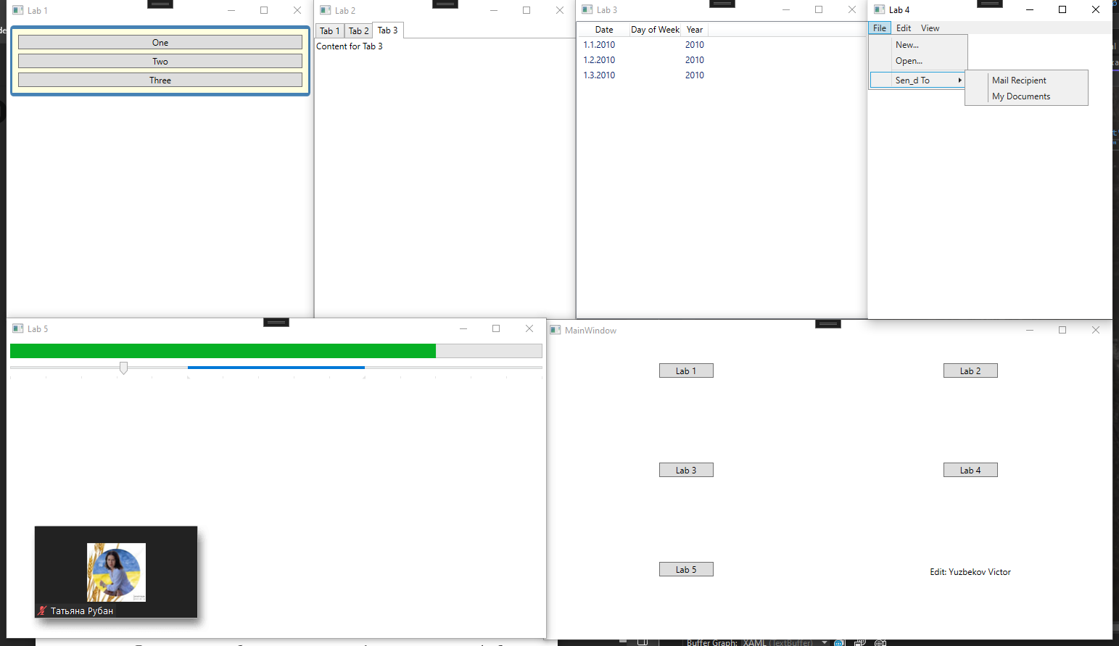

| MainWindow.xaml |
| --- |
| <Window x:Class="WpfApp2.MainWindow"  xmlns="http://schemas.microsoft.com/winfx/2006/xaml/presentation"  xmlns:x="http://schemas.microsoft.com/winfx/2006/xaml"  xmlns:d="http://schemas.microsoft.com/expression/blend/2008"  xmlns:mc="http://schemas.openxmlformats.org/markup-compatibility/2006"  xmlns:local="clr-namespace:WpfApp2"  mc:Ignorable="d"  Title="MainWindow" Height="450" Width="800">  <Grid>  <Grid.ColumnDefinitions>  <ColumnDefinition Width="*"/>  <ColumnDefinition Width="*"/>  </Grid.ColumnDefinitions>  <Grid.RowDefinitions>  <RowDefinition Height="*"/>  <RowDefinition Height="*"/>  <RowDefinition Height="*"/>  </Grid.RowDefinitions>  <Button Name="btn1" Grid.Row="0" Grid.Column="0" Content="Lab 1" HorizontalAlignment="Center" Margin="0,30,0,0" VerticalAlignment="Top" Width="75" Click="Click"/>  <Button Name="btn2" Grid.Row="0" Grid.Column="1" Content="Lab 2" HorizontalAlignment="Center" Margin="0,30,0,0" VerticalAlignment="Top" Width="75" Click="Click"/>  <Button Name="btn3" Grid.Row="1" Grid.Column="0" Content="Lab 3" HorizontalAlignment="Center" Margin="0,30,0,0" VerticalAlignment="Top" Width="75" Click="Click"/>  <Button Name="btn4" Grid.Row="1" Grid.Column="1" Content="Lab 4" HorizontalAlignment="Center" Margin="0,30,0,0" VerticalAlignment="Top" Width="75" Click="Click"/>  <Button Name="btn5" Grid.Row="2" Grid.Column="0" Content="Lab 5" HorizontalAlignment="Center" Margin="0,30,0,0" VerticalAlignment="Top" Width="75" Click="Click"/>  <Label Name="lbl1" Grid.Row="2" Grid.Column="1" Content="Edit: Yuzbekov Victor" HorizontalAlignment="Center" Margin="0,30,0,0"/>  </Grid>  </Window> |

| MainWindow.xaml.cs |
| --- |
| using System;  using System.Collections.Generic;  using System.Linq;  using System.Text;  using System.Threading.Tasks;  using System.Windows;  using System.Windows.Controls;  using System.Windows.Data;  using System.Windows.Documents;  using System.Windows.Input;  using System.Windows.Media;  using System.Windows.Media.Imaging;  using System.Windows.Navigation;  using System.Windows.Shapes;  namespace WpfApp2  {  /// <summary>  /// Interaction logic for MainWindow.xaml  /// </summary>  public partial class MainWindow : Window  {  public MainWindow()  {  InitializeComponent();  }  private void Click(object sender, RoutedEventArgs e)  {  Button b = (Button)sender;  Win1 w1 = new Win1();  Win2 w2 = new Win2();  Win3 w3 = new Win3();  Win4 w4 = new Win4();  Win5 w5 = new Win5();  switch (b.Content.ToString())  {  case "Lab 1":  w1.Title = "Lab 1";  w1.Show();  break;  case "Lab 2":  w2.Title = "Lab 2";  w2.Show();  break;  case "Lab 3":  w3.Title = "Lab 3";  w3.Show();  break;  case "Lab 4":  w4.Title = "Lab 4";  w4.Show();  break;  case "Lab 5":  w5.Title = "Lab 5";  w5.Show();  break;  default:  break;  }  }  }  } |

| Win1.xaml |
| --- |
| <Window x:Class="WpfApp2.Win1"  xmlns="http://schemas.microsoft.com/winfx/2006/xaml/presentation"  xmlns:x="http://schemas.microsoft.com/winfx/2006/xaml"  xmlns:d="http://schemas.microsoft.com/expression/blend/2008"  xmlns:mc="http://schemas.openxmlformats.org/markup-compatibility/2006"  xmlns:local="clr-namespace:WpfApp2"  mc:Ignorable="d"  Title="Win1" Height="450" Width="800">  <Grid>  <Border Margin="5" Padding="5" VerticalAlignment="Top"  Background="LightYellow" BorderBrush="SteelBlue"  BorderThickness="3,5,3,5" CornerRadius="3">  <StackPanel>  <Button Margin="3" Content="One"/>  <Button Margin="3" Content="Two"/>  <Button Margin="3" Content="Three"/>  </StackPanel>  </Border>  </Grid>  </Window> |

| Win2.xaml |
| --- |
| <Window x:Class="WpfApp2.Win2"  xmlns="http://schemas.microsoft.com/winfx/2006/xaml/presentation"  xmlns:x="http://schemas.microsoft.com/winfx/2006/xaml"  xmlns:d="http://schemas.microsoft.com/expression/blend/2008"  xmlns:mc="http://schemas.openxmlformats.org/markup-compatibility/2006"  xmlns:local="clr-namespace:WpfApp2"  mc:Ignorable="d"  Title="Win2" Height="450" Width="800">  <Grid>  <TabControl SelectedIndex="2">  <TabItem Header="Tab 1">Content for Tab 1</TabItem>  <TabItem Header="Tab 2">Content for Tab 2</TabItem>  <TabItem Header="Tab 3">Content for Tab 3</TabItem>  </TabControl>  </Grid>  </Window> |

| Win3.xaml |
| --- |
| <Window x:Class="WpfApp2.Win3"  xmlns="http://schemas.microsoft.com/winfx/2006/xaml/presentation"  xmlns:x="http://schemas.microsoft.com/winfx/2006/xaml"  xmlns:d="http://schemas.microsoft.com/expression/blend/2008"  xmlns:mc="http://schemas.openxmlformats.org/markup-compatibility/2006"  xmlns:local="clr-namespace:WpfApp2"  mc:Ignorable="d"  Title="Win3" Height="450" Width="800">  <Grid>  <ListView xmlns:sys="clr-namespace:System;assembly=mscorlib">  <ListView.View>  <GridView>  <GridViewColumn Header="Date" Width="70"/>  <GridViewColumn Header="Day of Week" DisplayMemberBinding="{Binding DayofWeek}"/>  <GridViewColumn Header="Year" DisplayMemberBinding="{Binding Year}"/>  </GridView>  </ListView.View>  <sys:DateTime>1/1/2010</sys:DateTime>  <sys:DateTime>1/2/2010</sys:DateTime>  <sys:DateTime>1/3/2010</sys:DateTime>  </ListView>  </Grid>  </Window> |

| Win4.xaml |
| --- |
| <Window x:Class="WpfApp2.Win4"  xmlns="http://schemas.microsoft.com/winfx/2006/xaml/presentation"  xmlns:x="http://schemas.microsoft.com/winfx/2006/xaml"  xmlns:d="http://schemas.microsoft.com/expression/blend/2008"  xmlns:mc="http://schemas.openxmlformats.org/markup-compatibility/2006"  xmlns:local="clr-namespace:WpfApp2"  mc:Ignorable="d"  Title="Win4" Height="450" Width="800">  <Grid>  <DockPanel LastChildFill="False">  <Menu DockPanel.Dock="Top">  <MenuItem Header="_File">  <MenuItem Header="_New..."/>  <MenuItem Header="_Open..."/>  <Separator/>  <MenuItem Header="_Sen_d To">  <MenuItem Header="Mail Recipient"/>  <MenuItem Header="My Documents"/>  </MenuItem>  </MenuItem>  <MenuItem Header="_Edit"/>  <MenuItem Header="_View"/>  </Menu>  </DockPanel>  </Grid>  </Window> |

| Win5.xaml |
| --- |
| <Window x:Class="WpfApp2.Win5"  xmlns="http://schemas.microsoft.com/winfx/2006/xaml/presentation"  xmlns:x="http://schemas.microsoft.com/winfx/2006/xaml"  xmlns:d="http://schemas.microsoft.com/expression/blend/2008"  xmlns:mc="http://schemas.openxmlformats.org/markup-compatibility/2006"  xmlns:local="clr-namespace:WpfApp2"  mc:Ignorable="d"  Title="Win5" Height="450" Width="800">  <Grid>  <StackPanel>  <ProgressBar Value="80" Height="20" Margin="5"/>  <Slider Maximum="30" Value="25" TickPlacement="BottomRight" TickFrequency="2"  IsSelectionRangeEnabled="True" SelectionStart="10" SelectionEnd="20"/>  </StackPanel>  </Grid>  </Window> |